Part-2 Chapter-5
Aplia Homework: An Introduction to Macroeconomics

1. Microeconomics and macroeconomics
Determine whether each topic in the following table would more likely be studied in microeconomics or macroeconomics.
Topic | Microeconomics | Macroeconomics
The effects of the Internet on the pricing of used cars | _____ | _____
The effect of government regulation on a monopolist’s production decisions | _____ | _____
The effect of a large government’s budget deficit on the economy’s price level | _____ | _____

2. Activities included (and not included) in the calculation of GDP
The gross domestic product (GDP) of the United States is defined as the _______ all _______ by _______ in a given period of time, usually a year.

Based on this definition, indicate which of the transactions in the following table will be included in (that is, directly increase) the GDP of the United States in 2021.

Transaction | 2021 GDP
 | Included | Excluded
Roadway Motors, a U.S. automobile company, produces a convertible at a plant in Germany on March 4, 2021. Roadway Motors imports the convertible into the United States on May 28, 2021. | _____ | _____
Awake Cafe, a U.S. coffee company, produces a latte at its location in Minneapolis on January 18, 2021. It sells the latte to a customer immediately. | _____ | _____
You chop down a cherry tree on your property in California and make a dining room table in 2021. This table does not pass through an organized market, but a similar table sells for $800 in a local furniture store. | _____ | _____
Treehoppers, a U.S. lumber company, produces wood at a plant in Oregon on September 19, 2021. It sells the wood to Build it and Partners, a developer, for use in the production of a new house that will be built in the United States in 2021. (Note: Focus exclusively on whether production of the wood increases GDP directly and ignore the effect of production of the new house on GDP.) | _____ | _____
Sofa land, a Swedish furniture company, produces a table at a plant in Virginia on December 12, 2021. It sells the table to a college student on December 24, 2021. | _____ | _____

3. Limitations of GDP
Although GDP is a reasonably good measure of a nation’s output, it is not an accurate measure of a nation’s well-being.
Which of the following options are either not accounted for or are measured inaccurately in calculations of GDP for the United States? Check all that apply.

The components of a U.S.-made tablet that are produced in China
The quality of goods available to consumers
Federal government pay checks to soldiers
The costs of overfishing and other overly intensive uses of resources
The value of babysitting services, when the babysitter is paid in cash and the transaction isn’t reported to the government

4. Key facts about economic fluctuations
The following graph approximates business cycles in the United States from the first quarter of 1955 to the third quarter of 1959. The vertical blue bar coincides with a period of six or more months of declining real gross domestic product (real GDP).
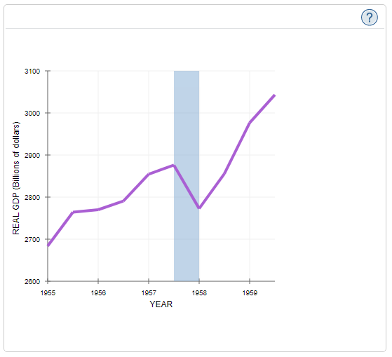
Notice that real GDP trends upward over time but experiences ups and downs in the short run. These short-run fluctuations in real GDP are often referred to as _________.

True or False: Small ups and downs in real GDP follow a consistent, predictable pattern.

True
False

Which of the following probably occurred as the U.S. economy experienced increasing real GDP in 1958? Check all that apply.

Total real income increased.
The unemployment rate declined.
Consumer spending declined.
Corporate profits increased.

5. Using the AD-AS model to understand U.S. economic history
During World War II, the U.S. government spent billions of dollars on aircraft, ships, and munitions. This government spending raised both employment and output but also caused the prices of many goods and services to rise.
The following graph shows the aggregate demand (AD) and aggregate supply (AS) curves for the United States in 1941.
Shift one of the curves on the following graph to illustrate the effect of increased U.S. government spending during World War II.

6. Macroeconomic stabilization: Combating unemployment and inflation
The following graph shows the aggregate supply (AS)(AS) and aggregate demand (AD)(AD) curves of a hypothetical economy. Suppose that, in the absence of government intervention, the economy is in equilibrium at point EE. Additionally, suppose that the price level corresponding to point EE is considered too high, so the price level would be rising too rapidly if the economy were to move to point EE, and that the government decides to step in to improve economic conditions.

On the following graph, shift the relevant curve or curves to illustrate the result of the government intervention.

Reduction in government spending
Tax hikes
Increases in government spending
Tax cuts

7. The Great Recession and the collapse of the housing bubble
Consider the following dialogue about the crash of the housing market and the Great Recession of 2007–2009 between two students in an economics class.
CARLOS: Hi, Deborah. I’m intrigued to see how macroeconomics allows us to explain recent economic events such as the Great Recession that affected so many people. But there’s one thing I don’t understand. Was the collapse of the housing bubble the only cause of the recession, or were there other factors as well?
DEBORAH: Hi, Carlos. I agree that macroeconomic theory offers an entirely new perspective on how the economy works. To answer your question, the crash of the housing market was a major factor but not the only cause of the Great Recession. The professor mentioned that the _______ system deteriorated as well, an event that deepened the economic downturn even further.
CARLOS: I see. So the bursting of the housing bubble caused the initial decline in aggregate demand. Then the financial crisis caused aggregate demand to decline even more. Could you also help me understand how to use the aggregate demand and aggregate supply model to explain the effect of the bursting of the housing bubble on GDP?
DEBORAH: The professor used the aggregate demand and aggregate supply model to show that _______ in spending on construction of new houses causes an _______ shift of the aggregate ________ curve.

CARLOS: I see it now. And as a result, GDP ________ as well. I would like to use a graph to illustrate what you’ve just said.

On the following graph showing the aggregate demand (AD) and aggregate supply (AS) curves, shift the relevant curve to illustrate Deborah’s explanation of the effect of the collapse of the housing bubble on domestic product.

